PANCAKES

INGREDIENTS:

160 g of flour
1 tbsp sugar
3.5 g of baking powder
250 ml of milk
15 g melted butter
1 egg
1 pinch of sale

1.
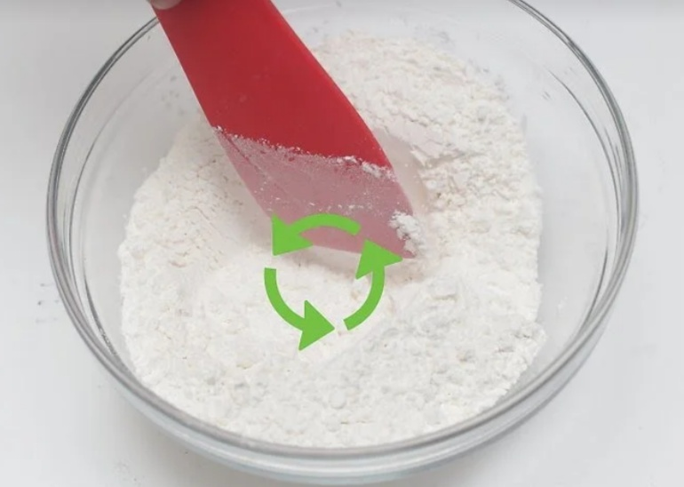
1. Mix the dry ingredients. Pour flour, sugar and baking powder into a bowl, then add a pinch of sale. Stir until you get a uniform result.

2.
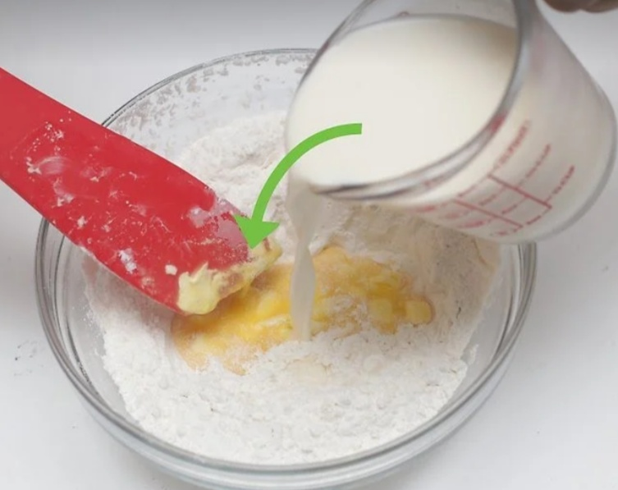
2. Add the wet ingredients. Pour milk, egg and melted butter into the bowl. Mix until you get a smooth result. slightly away to disappear the yellow stars of the yolk.

3.
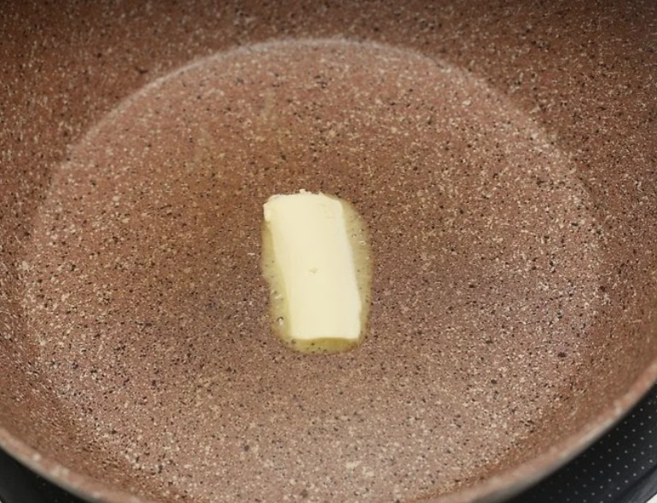
3. Melt the butter in a boiling pan. Put the pan on a medium-high heat. Add a generous piece of butter (15-30 g). Use a spatula to spread the butter on the surface and coat the bottom of the pan. Let it melt completely and warm up to create foam.

4.
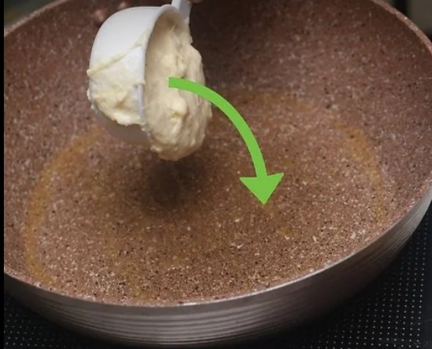
4. Pour 1/3 of the mixture at a time. If the pan is large enough, pancakes can be cooked in several parts at the same time.

5.
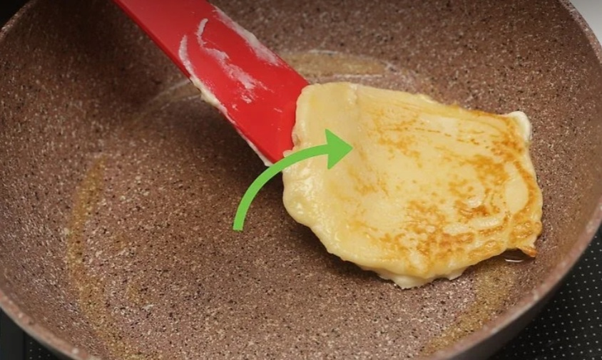

5. Turn them over after a few minutes. After 3 minutes, use a spatula to lift the edges of the pancake. If it lifts smoothly from the pan and has taken on a nice golden color, it is ready to be turned.

RESULT:

